**Border Utilities**

Use border utilities to add or remove an element’s borders. Choose from all borders or one at a time.

Additive

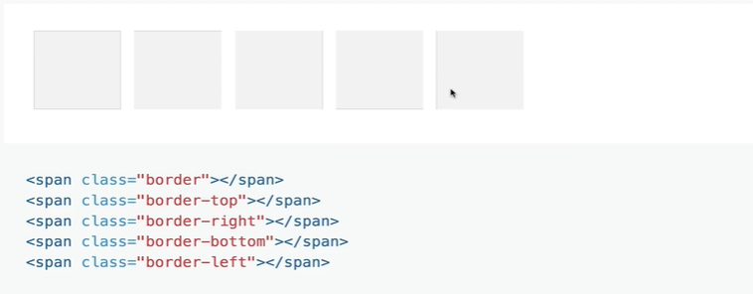

Subtractive

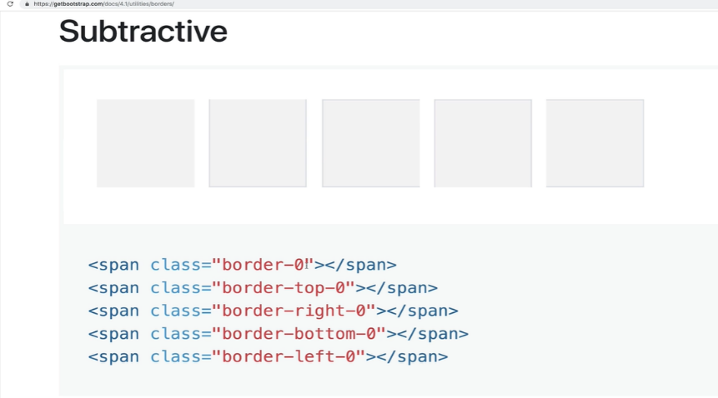

We can also add color to our border

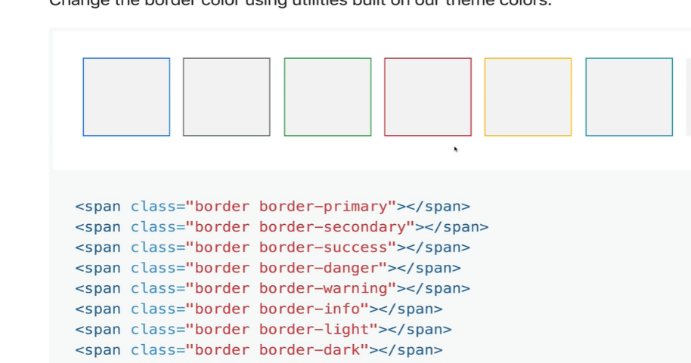

Border radius

We can add rounded corners to our borders

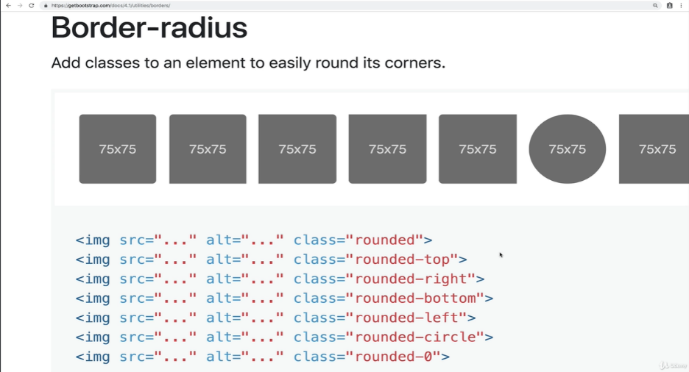

*<!—Border 🡪*

*<h5 class= “border border-danger rounded-top”>GIVE ME A BORDER</h5>*

*Output:*



*It has rounded top at left and right ends*

*<h5 class= “border-top border-info”>GIVE ME A BORDER</h5>*



*<h5 class= “border border-left-0 border-warning”>GIVE ME A BORDER</h5>*



Bootstrap-4 also provides margin and padding properties for free.

We can use them by other utility classes. Under Spacing inside of utilities, we would have margin and padding.

“m” stands for classes that set margin

“p” stands for classes that set padding

And then we have to say which side of our element does the padding or the margin goes

t – for classes that set margin-top or padding-top

b – for classes that set margin-bottom or padding-bottom

l – for classes that set margin-left or padding-left

r – for classes that set margin-right or padding-right

x – for classes that set both left and right

y – for classes that set both top and bottom

or we can just leave it blank and only declare “m” or “p” and that will set margin or padding to all four sides of our element.

And then we have six different values including zero. Zero up until for amount of padding or amount of margin.

0 – for classes that eliminate the margin or padding by setting it to 0.

1 – (by default) for classes that set the margin or padding to $spacer * .25

2 – (by default) for classes that set the margin or padding to $spacer * .5

3 – (by default) for classes that set the margin or padding to $spacer

4 – (by default) for classes that set the margin or padding to $spacer * 1.5

5 – (by default) for classes that set the margin or padding to $spacer * 3

Auto – for classes that set margin to auto

pt0 that would be padding-top zero

pl5 that would be padding left five

*<button class= “btn btn-info”>P0</button>*

*Output:*



This is the default button that how it looks like

Now if we do “p-0” as class it says to remove all paddings from all sides. Then we get the following button.

So, this button has no padding around it.

*<button class= “btn btn-info p-0”>P0</button>*

*<button class= “btn btn-info p-1”>P1</button>*

*<button class= “btn btn-info p-2”>P2</button>*

*<button class= “btn btn-info p-3”>P3</button>*

*<button class= “btn btn-info p-4”>P4</button>*

*<button class= “btn btn-info p-5”>P5</button>*

*Output:*

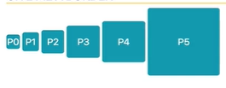

The numbers 0,1,2,3,4,5 are not padding they are levels. These numbers are multiplied with a certain number called $spacer to get the padding. The number $spacer can be set at the browser.

*<button class= “btn btn-info pt-5”>Pt-5</button>*

*<button class= “btn btn-info pb-4”>Pb-4</button>*

*<button class= “btn btn-info py-5”>Py-5</button>*

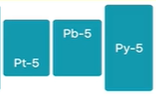

So, here Pt-5, adds padding to the top from the center

Pb-5 adds padding from the center to the bottom

Py-5 adds padding adds padding at the top and bottom from the center

*<p class= “bg-success text-white m-0”>I AM M-0</p>*

*<p class= “bg-success text-white m-1”>I AM M-1</p>*

*<p class= “bg-success text-white m-2”>I AM M-2</p>*

*<p class= “bg-success text-white m-3”>I AM M-3</p>*

*<p class= “bg-success text-white m-4”>I AM M-4</p>*

*<p class= “bg-success text-white m-5”>I AM M-5</p>*

*Output:*

